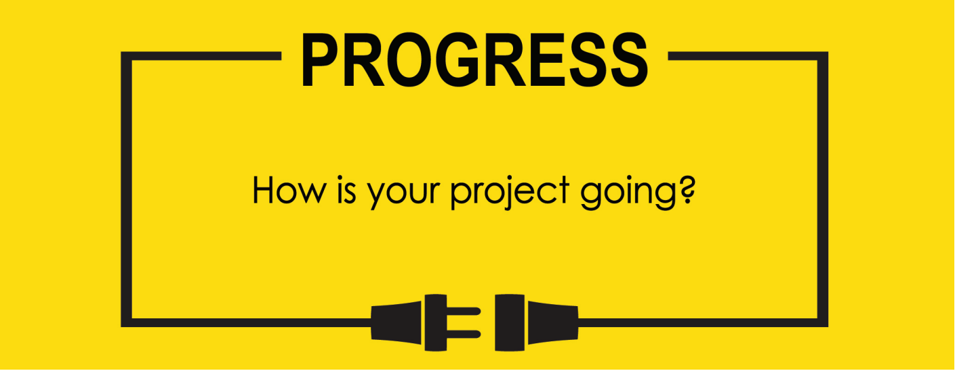

**Name: Zach Wilcox**

**Project Title: GreenBox**

**Previous Goals**

What were your three goals from last week? Were you able to complete them? If so, select Completed. If not, select the level of completion and explain in the Notes section why the goal was not completed, what still remains to be done, and when you expect to finish work on the goal.

Goal #1 from last week: Finish box build

**Status:** _____Completed ___x__Partially Completed _____No Progress

**Notes:**

Adhesive has not yet arrived. Some smaller holes have been made between chambers, but overall minimal progress.

Goal #2 Power the cooling unit/finish unit housing

**Status:** ___x__Completed _____Partially Completed _____No Progress

**Notes:**

Unit can be easily mounted to hole made between chambers, and the cooling unit was connected to power source temporarily for testing. The cooling unit should be ready to go once final assembly is started.

Goal #3 from last week: get knob/potentiometers and assemble those circuits for use in GPIO control code

**Status:** __x___Completed _____Partially Completed _____No Progress

**Notes:**

Using potentiometers that are slightly different from the ones intended for final assembly, the circuits and code have been completed for the input portion of the project. However, since the input potentiometers are of a different resistance to the final potentiometers, I did not start the computations for the output yet.

**Next Three Goals**

Choose three subtasks from your Gantt chart and use them to form goals that you plan to complete this week. In the text box beneath each goal, give details about what you plan to accomplish. Include details such as what materials are needed, how many hours each day you plan to devote to the task, and so on.

NOTE: THESE ARE INDIVIDUAL GOALS THAT YOU PLAN TO ACCOMPLISH. THESE ARE NOT TEAM GOALS.

**Goal #1:** Finish box build

**Goal #2:** Begin build on custom wicking humidifier

**Goal #3:** Begin output for GPIO code

Potentiometer connection and code

Previous Gantt chart.

Box assembly extended again.

